УО «Белорусский государственный университет информатики и радиоэлектроники»

Кафедра ПОИТ

Отчет по лабораторной работе №1.2

по предмету «Основы алгоритмизации и программирования»

Вариант 20

Выполнил:

Егоров А.С.

Гр. 351005

Проверил:

Данилова Г. В.

Минск 2023

**Задание:**

Найти корень уравнения ln(7,622x) – 8,59х + 5 = 0 с точностью ε методом простой итерации.

**Код программы Delphi:**

Program Exercise3;

Uses

System.SysUtils;

// initialization

Var

Counter: Integer = 0;

Eps: Real = 0;

X: Real = 0;

XLast: Real = 0;

IsFinding: Boolean = False; // for task

GoodFlag: Boolean = False; // for exit loop

Begin

// output the task

Writeln('Program solves this example: Ln(7.622x) - 8.59x + 5.');

Writeln('It is recommended to input epsilon in standard form.');

Writeln('Example: 1e-9');

Writeln('Or using normal input.');

Writeln('Example: 0.1');

// loop for checking inputted eps

Repeat

Try

Writeln('Enter eps:');

Readln(Eps);

If Eps > 0.1 Then

Raise Exception.Create('Epsilon is too big!!!');

If Eps < 1.0E-17 Then

Raise Exception.Create('Epsilon is too low!!!');

GoodFlag := True;

Except

On E: Exception Do

Begin

Write(E.Message);

Writeln(' Try again.');

End;

End;

Until GoodFlag;

// output some more info

Writeln('To start program also needs to input X0:');

// loop for checking inputted X0

GoodFlag := False;

Repeat

Try

Writeln('Enter X0:');

Readln(XLast); // x0

If (XLast < 0) Or (XLast = 0) Then

Raise Exception.Create

('X0 cannot be less or equal than 0, because in the task there is

logarithm(7.622x > 0)!!!');

If 100 / (859 * XLast) > 1 Then

Raise Exception.Create

('The problem is not solvable using the inputted X0!!!');

GoodFlag := True;

Except

On E: Exception Do

Begin

Write(E.Message);

Writeln(' Try again.');

End;

End;

Until GoodFlag;

Writeln(#9, 'N', #9, '| X - 1', #9, '|', #9, 'X');

Writeln('-------------------------------------------------');

While IsFinding = False Do

Begin

X := (Ln(7.662 * XLast) + 5) / 8.59;

Writeln(Counter:9, '|':8, XLast:11:5, #9, '|', X:11:5);

If Abs(X - XLast) < Eps Then

IsFinding := True

Else

XLast := X;

Counter := Counter + 1;

End;

// output

Writeln;

Writeln('The answer of this task is ', X:1:5);

// freeze console

Writeln('Press enter to exit...');

Readln;

End.

**Код программы С++:**

#include<iostream>

#include<math.h>

#include<iomanip> // for std::setw() and std::left nad std::right

int main()

{

// initialization

int counter = 0; //for input

double eps = 0, xLast = 0, x = 0;// xLast is x0

bool isFinding = false, // for task

goodFlag = false; // for exit loop

// output the task

std::cout << "Program solves this example: Ln(7.622x) - 8.59x + 5 = 0.\n"

<< "It's recommended to input epsilon, using standard form.\n"

<< "Example: 1e-9\n"

<< "Or using normal input.\n"

<< "Example: 0.1\n";

// loop for check inputted eps

do

{

try

{

//input

std::cout << "Enter eps:\n";

std::cin >> eps;

if (std::cin.get() != '\n')

{

std::cin.clear();

std::cin.ignore(20000,'\n');

throw std::exception("Invalid type!!!");

}

if (eps > 0.1)

throw std::exception("Eps is too big!!!");

if (eps < 1.0e-17)

throw std::exception("Eps is too little!!!");

goodFlag = true;// to exit the loop if user entered correct epsilon

}

catch (const std::exception& ex)

{

std::cout << ex.what() << " Try again.\n";

}

} while (!goodFlag);

// output some more info

std::cout << "To start program also needs to input X0:\n";

// loop for check inputted X0

goodFlag = false;

do

{

try

{

std::cout << "Enter X0:\n";

std::cin >> xLast;

if (std::cin.get() != '\n')

{

std::cin.clear();

std::cin.ignore(20000, '\n');

throw std::exception("Invalid type!!!");

}

if (xLast < 0 || xLast == 0)

throw std::exception("X0 cannot be less or equal than 0, because in the

task there's the logarithm!!!(7.622x > 0)");

// make sure that we can solve this task with current X0

if ((double)100 / ((double)859 * xLast) >= 1)

throw std::exception("The problem is not solvable using the inputted

X0!!!");

goodFlag = true;// to exit the loop if user entered correct limits

}

catch (const std::exception& ex)

{

std::cout << ex.what() << " Try again.\n";

}

} while (!goodFlag);

// main block

// creating table

std::cout << std::endl << std::setw(6) << std::left << " n"

<< std::setw(13) << std::left << "| x-1"

<< "| x" << std::endl

<< "--------------------------------\n";

while (!isFinding)

{

x = (log(7.622 * xLast) + 5) / 8.59;

// output

std::cout << std::setw(5) << std::left << counter++ << " | "

<< std::setw(10) << std::left << xLast << " | "

<< x << std::endl;

// if we find the right X

if (abs(x - xLast) < eps)

isFinding = true;

else

xLast = x;

}

// output

std::cout << "\nThe answer of this task is "

<< x << std::endl;

return 0;

}

**Код программы Java:**

import java.util.Scanner;  
import java.math.*;  
  
public class Main {  
 public static void main(String[] args) {  
 //initialization  
 boolean goodFlag = false, //for exit loop  
 isFinding = false; // for task  
 int counter = 0;  
 double eps = 0,  
 xLast = 0, // X0  
 x = 0;  
 Scanner in = new Scanner(System.in);  
 //output the task  
 System.out.print("""  
 Program solves this example: Ln(7.622x) - 8.59x + 5 = 0.  
 It's recommended to input epsilon, using standard form.  
 Example: 1e-9  
 Or using normal input.  
 Example: 0.1  
 """);  
 // loop for check inputted eps  
 do {  
 try {  
 //input  
 System.out.println("Enter eps:");  
 eps = Double.parseDouble(in.nextLine());  
 if (eps > 0.1) {  
 System.out.print("Eps is too big!!!");  
 throw new Exception();  
 }  
 if (eps < 1.0e-17) {  
 System.out.print("Eps is too little!!!");  
 throw new Exception();  
 }  
 goodFlag = true; // to exit the loop if user entered correct epsilon  
 }  
 catch (Exception ex)  
 {  
 if (ex.getMessage() != null)  
 System.out.print("Invalid type!!!");  
 System.out.println(" Try again.");  
 }  
 } while(!goodFlag);  
 // output some more info  
 System.out.println("Enter x to start the calculation with:");  
 // loop for check inputted X0  
 goodFlag = false;  
 do {  
 try {  
 System.out.println("Enter X0");  
 xLast = Double.parseDouble(in.nextLine());  
 if (xLast < 0 || xLast == 0) {  
 System.out.print("X0 cannot be less or equal than 0, because in the

task there's logarithm!!! (7.622x > 0)");  
 throw new Exception();  
 }  
 if ((double)(100)/((double)(859) * xLast) > 1)  
 {  
 System.out.print("The problem is not solvable using the inputted

X0!!!");  
 throw new Exception();  
 }  
 goodFlag = true; // to exit the loop if user entered correct limits  
 }  
 catch (Exception ex)  
 {  
 if (ex.getMessage() != null)  
 System.out.print("Invalid type!!!");  
 System.out.println(" Try again.");  
 }  
  
 }while(!goodFlag);  
 in.close();  
 // main block  
 //creating table  
 System.out.printf(" %-5s|", "N");  
 System.out.printf(" %-6s|", "X-1");  
 System.out.println(" X");  
 System.out.println("--------------------------------");  
 while(!isFinding)  
 {  
 x = (Math.log(7.622 * xLast) + 5) / 8.59;  
 System.out.printf("%-10s|", counter);  
 System.out.printf("%f |", xLast);  
 //System.out.printf("%-10s|", xLast);  
 System.out.printf("%f\n", x);  
 if (Math.abs(x - xLast) < eps)  
 isFinding = true;  
 else  
 xLast = x;  
 counter += 1;  
 }  
 // output  
 System.out.printf("\nThe answer of this task is %f.\n", x);  
  
 }  
}

**Скриншоты:**

**Delphi:**

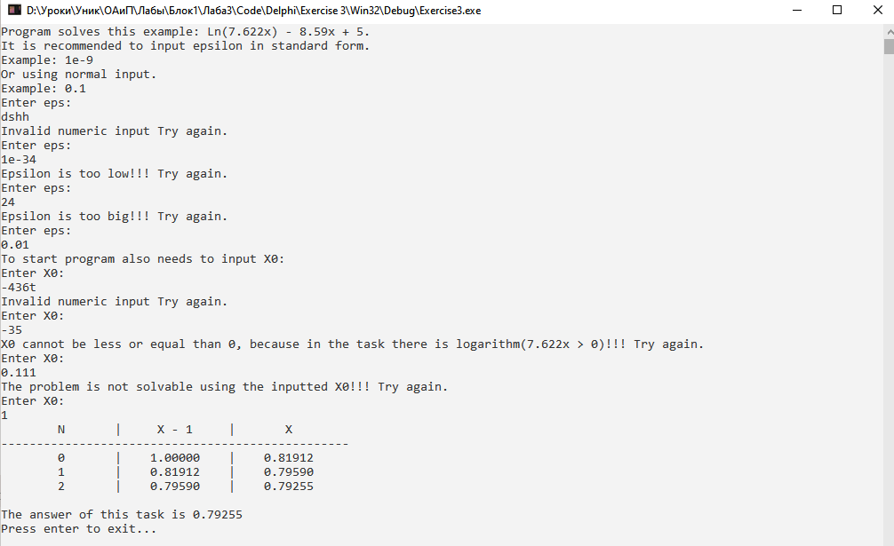

**C++:**

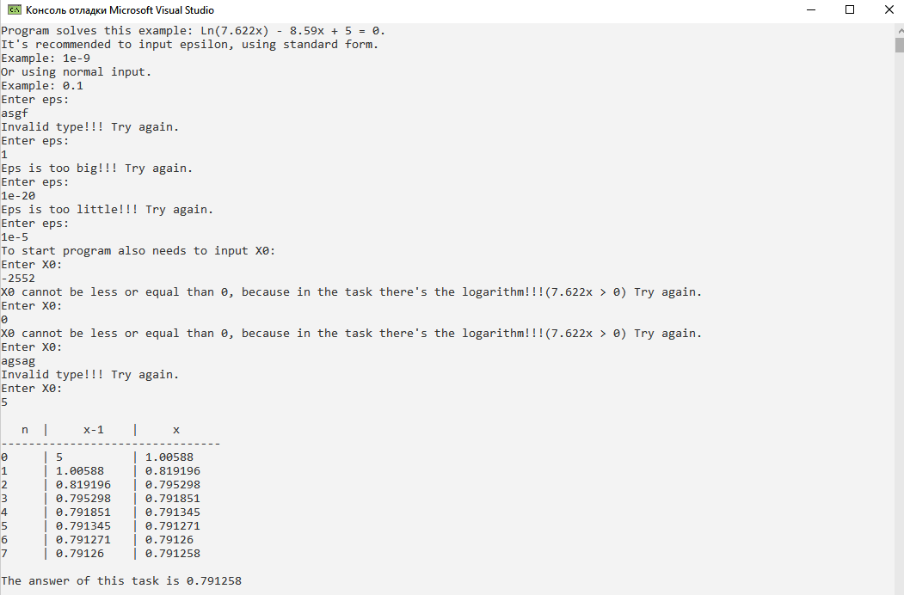

**Java:**

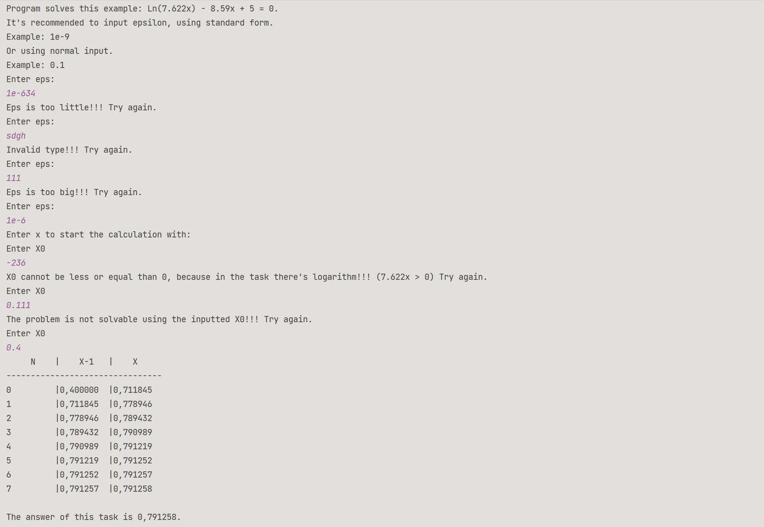

**Блок-схема:**

